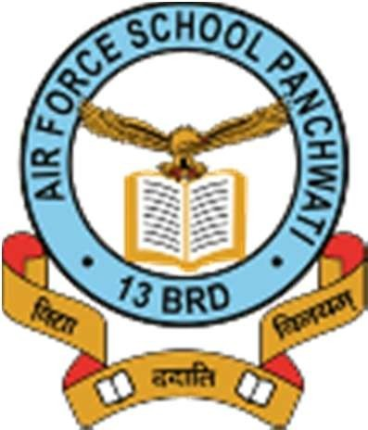
VACANCY FOR THE POST OF

TGT, PRT, NTT, SPECIAL EDUCATOR, CLERK AND LAB ATTENDANT
1. Applications are invited for the following posts in AF School, Panchwati.

Sl No | Appointment | Qualification
1. | a) TGT HWT  b) TGT Social-Sci  c) TGT Science d) TGT Maths  e) TGT English  f) TGT Computer  (Salary- 33,000 P/M) | (i) A Masters or a Bachelor’s Degree from any University recognised by the Govt of India/ UGC/ AICTE with a minimum marks of 50 percent in the subject and 50 percent in the aggregate, including electives and languages, in the combination of subjects as under :-  TGT (English) : English as an elective subject at Degree level  TGT (Social Studies): Any two out of History, Geography, Economics or Political Science, of which one must be either History or Geography (ae)  TGT (Maths) : Maths with any two out of Physics, Chemistry, Electronics, Computer Science or Statistics  TGT (Science) : Botany, Zoology and Chemistry (All three subjects should have been studied)  Health Wellness : Diploma in Counselling from a Teacher recognised University or BA/ BSc Psychology with Educational Psychology/ Counselling Psychology from a recognised University or MA/ MSc in Counselling Psychology or MA MSc Psychology with Counselling Psychology as 45 specialisation or MA/MSc in Applied Psychology with Counselling Psychology from a recognised University  (TGT (Computer) : PGDCA/ MCA/ BE from any Govt recognised institution  (ii) A Bachelor’s Degree from any University recognised by the Govt of India/ UGC/AICTE, However, B.Ed. degree is not mandatory for the post of TGT (Computers), TGT (Music), TGT (Games), TGT (Drawing)and Health Wellness Teacher  (iii) A Bachelor of Education Degree or its equivalent from a college/ university recognised by Govt of India/AICTE/UGC/National Council of Teachers Education.  (iv) Should be in the age group of 21 to 50 years as on 01 July of the academic year in which the post is being filled.
2. | PRT  (02 Vacancies)  (Salary- 28,500 P/M) | (i) A Bachelor’s Degree from any University recognised by the Govt of India/ UGC/AICTE, with minimum marks of 50 percent in the aggregate.  (ii) A Bachelor of Education Degree or its equivalent from a college/ university recognised by Govt of India/AICTE/UGC/National Council of Teachers Education.  (iii) Should be in the age group of 21 to 50 years as on 01 July of the academic year in which the post is being filled.  (iv) Should be able to read, write and communicate fluently in English.
3. | NTT  (02 Vacancies)  (Salary – 18,000 P/M) | (i) Senior Secondary with Nursery Teachers Training diploma or diploma in Nursery/Montessori/Pre-Primary Teachers Training or Diploma in Elementary Education from a Govt recognised institution. While candidates with higher qualifications may apply, preference is to be given to candidates with diploma in Nursery/Montessori Training.  (ii) Should be in the age group of 21 to 50 years as on 01 July of the academic year in which the post is being filled.
4. | Special Educator  (01 Vacancy P/M) | (i) XII pass and 2 year D.ED Special Educationin any of the category of disability  or  (ii) XII passed and 01 year diploma (DSE) in any of the category of Disability  or  Any other quivelent qualifications approved by RCI
5. | Clerk  (02 Vacancies)  (14,500) | - Graduate from a Govt recognised University.  (ii) Typing speed of at least 40 wpm in English.  Should be in the age group of 25 to 50 years as on 01 July of the academic year in which the post is being filled.
6. | Lab Attendant (01 Vacancy )  (14,000 P/M ) | (a) 10+2 with Science.  (b) Should be in the age group of 21 to 50 years as on 01 July of the academic year in which the post is being filled
2. Duly filled application available on website along with educational testimonials/experience certificates and affixed photograph should be addressed to Executive Director, Air Force School Panchwati, Palam, and New Delhi 10 and deposited at Admin office latest by 23rd March 24 or email to afspanchwati@gmail.com.

